Riphah International University Of Lahore

Name:
Hanzla Ahmad

SAP ID:
61002

Subject:
Computer Organization and Assembly Language

Submitted to:
Mrs. Amna Bibi
Lab 3
Task 1
Take two integer as input, and output the greater one.

Source Code:
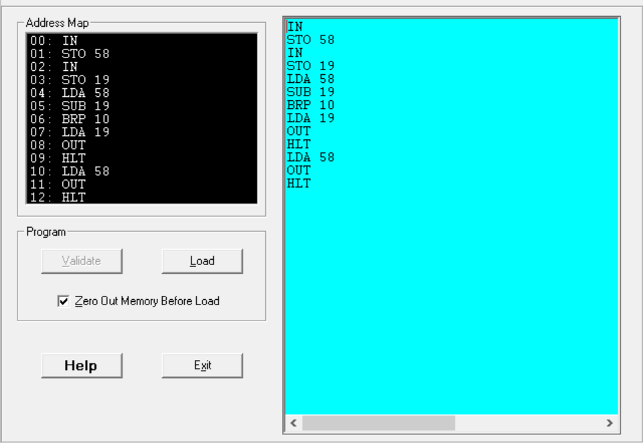

Output:
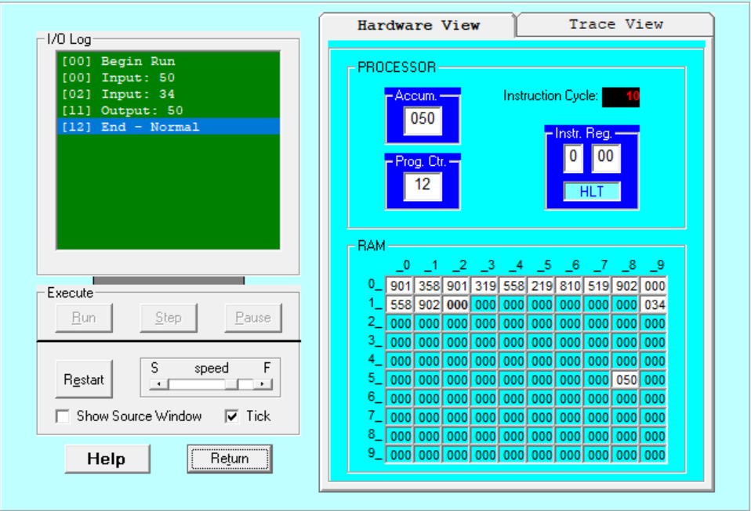
Explanation:
First, we take the input and store it at the address 58 then we take the second Input and stored it at the address 19 then we will load the number at address 58 after that we will subtract the number that is at address 19 then we check if the number is positive or zero through BRP if it is positive or zero then jump to the step 10 if it is not positive or 0 then it will proceed to the next step which is output the number and ends the program but if it is positive or zero then it will jump to the step 10 which it first load the number at address 58 then it will output the number and ends the program.
Task 2

Source Code:
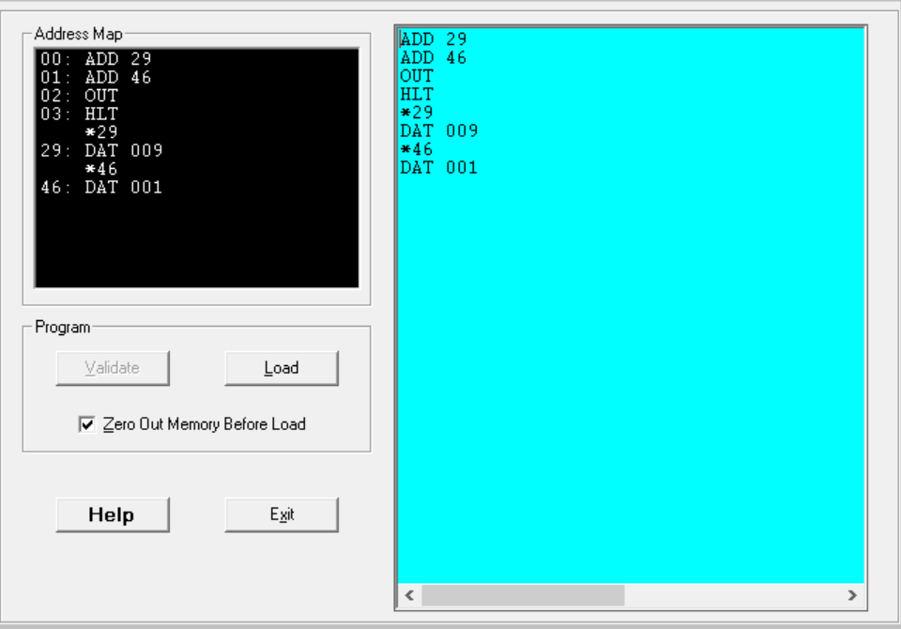

Output:
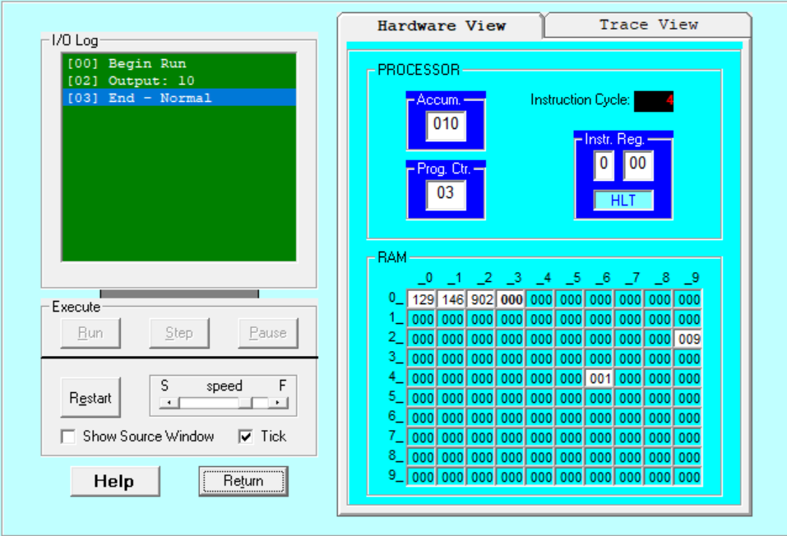

Explanation:
First, we take 2 numbers 29 and 46 hardcoded at address 29 and 46 with values 009 and 001 that will be added and we’ll print it out and the output is 10 and after that program will end.

